paradise creek watershed
restoration and protection plan
A BRODHEAD WATERSHED ASSOCIATION PROJECT

PHASE I EXECUTIVE SUMMARY
- Introduction
- Project Description
- Resident Survey
- Build-Out Analysis
- Land Use and Impervious Cover Survey
- Macroinvertebrate and Fish Data Gap Analysis
- Water Chemistry Data Gap Analysis
- Phase II Synopsis

Introduction:
A watershed is considered absolutely everything contained within an area of land that drains into a specific body of water. As such, the watershed defines the character and aesthetic beauty of a geographical region, as well as the health of local natural resources. In the Poconos, and specifically in the sub-watershed created by the Paradise Creek, aesthetic beauty is of paramount importance to the character of the community, and residents depend on the health and sustainability of natural resources like groundwater and surface water for survival.
Changes made to the natural attributes of the land in a watershed have a direct impact on the health of a watershed. Changes can be natural or man-made. Streams can meander, changing the course of flow and interacting with the soils and rocks that define stream banks. Invasive species, like the hemlock wooly adelgid, can destroy whole stands of forest, altering existing habitats and significantly impacting both flora and fauna. Scientific studies have confirmed that man-made alterations to natural drainage patterns, and specifically the creation of large impervious surfaces that do not allow stormwater to seep back into the native soils, represent one of the greatest threats to the health of any watershed.
Located in the center of the fastest growing region of Pennsylvania, development and related infrastructure requirements may threaten the very reason residents and businesses are drawn to the area. Without sound land use planning and controls, the Paradise watershed could fall victim to the urban sprawl that has drastically altered the character and water resources of countless communities. Appropriate regional planning, zoning, stormwater management, floodplain control, stream bank protection, and public education and outreach, combined with adequate enforcement of existing county, state and federal environmental protection rules can allow economic growth and development to occur in a manner that safeguards the Paradise Creek Watershed.
The Paradise Creek Watershed
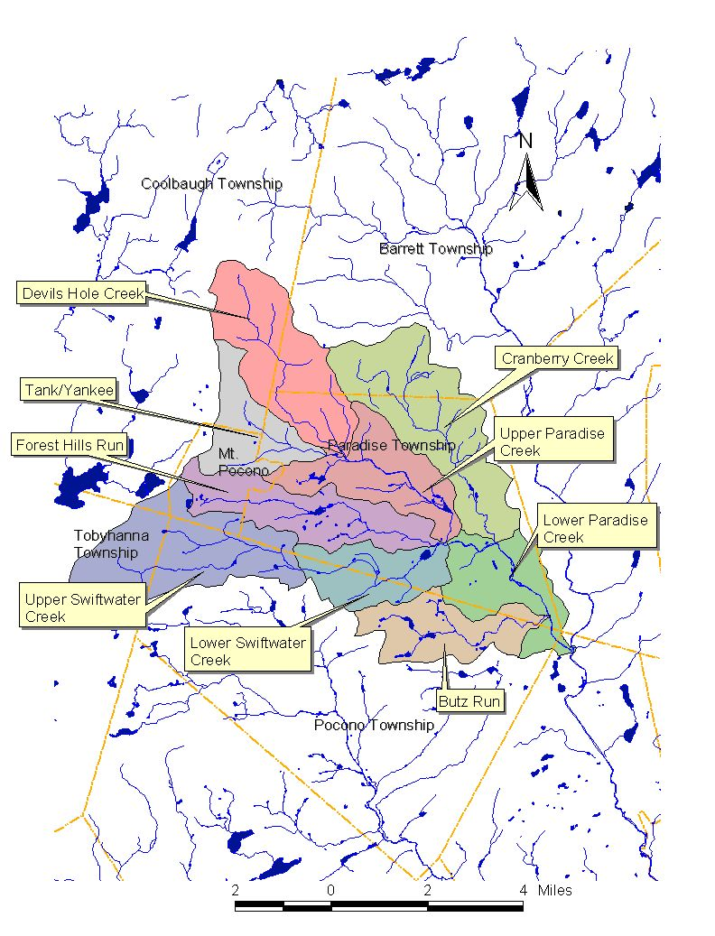

Project Description:
The Paradise Creek Watershed Assessment and Protection Plan Project is a comprehensive study of one portion of the larger Brodhead Watershed in northeast Pennsylvania, located within the Delaware River Basin. The study is sponsored by the Brodhead Watershed Association and funded through a Growing Greener Grant from the Pennsylvania Department of Environmental Protection. The study includes contributions of in-kind services from the Brodhead Watershed Association, Monroe County Conservation District, Monroe County Planning Commission, Aquatic Resource Consulting, and Wilkes University. Additional contractors include the Delaware River Basin Commission, United States Geological Survey, Borton-Lawson Engineering, Castle Valley Consulting, U.S. Filter Engineering and Construction, and the Mount Pocono Municipal Authority. Additional participants and supporters include the Pennsylvania Department of Environmental Protection, Pennsylvania Department of Transportation, Pennsylvania Fish and Boat Commission, Henryville Conservation Club, Brodhead Protective Association, Aventis Pasteur, Inc., Paradise Falls Lutheran Association, Lake Swiftwater Club, Concerned Citizens of Barrett Township, Pro Paradise Valley, Inc., and the Stroudsburg Municipal Authority. The Paradise Creek Watershed Assessment and Protection Plan Project also enjoys the support of the Monroe County Board of Commissioners and all five municipalities located within the watershed, including Paradise Township, Barrett Township, Pocono Township, Coolbaugh Township, Tobyhanna Township and Mount Pocono Borough.

The goal of the Paradise Creek Watershed Assessment and Protection Plan Project is to fully assess existing conditions in the watershed and to develop a management plan describing strategies to protect the region’s natural resources. The project was designed in three phases, covering a three-year period. Phase I of the study was intended to evaluate existing data and determine what additional studies were required to fully assess the watershed. Phase II of the study, which is in progress, is intended to fill those data gaps. Phase III of the study will be the development of a Paradise Creek Watershed Management Plan.
Phase I of the project began when the grant was awarded, on August 7, 2002. Phase I included a survey of property owners in the watershed to establish appropriate community-based goals and targets, a land use evaluation, a build-out analysis, and an impervious cover survey. Phase I also included a comprehensive evaluation of all existing data pertaining to water chemistry and biological habitats in the Paradise Creek drainage area. The Phase I research allowed the technical team to recommend additional studies to fill gaps in the existing data, and to modify some contractors’ scopes of work to ensure adequate and appropriate information about the watershed would be generated. Phase II of the study will be completed by May 2004.
Study results can be viewed on the Paradise Creek Watershed website, developed by the Pocono Mountain High School Environmental Club under the leadership of Faculty Advisor Neil McGovern, currently located at paradisecreekwatershed.org.

Resident Survey:
A resident survey was circulated to determine the needs and concerns of the community. Forty-eight percent of watershed residents who responded to the project survey believe new growth and development can occur without impacting water supplies and water quality if adequate safeguards are in place. But 41 percent of those surveyed did not believe adequate safeguards are currently in place, and over 48 percent were unsure. The survey results indicate a diverse range of opinions regarding growth in the watershed. Eighteen percent of those surveyed agreed they would be more supportive of watershed protection initiatives in the Poconos if they knew the initiatives would promote continued growth and development, while 53 percent claimed they would be more supportive if they knew these initiatives would slow or inhibit new development.
Over 59 percent of those who responded and indicated they would attend public meetings associated with the study wanted to keep track of how the project team is spending their tax dollars. Most (91.5 percent) want to learn more about the health of the Paradise Creek Watershed. Over half want to meet the team of scientists who are conducting the study, and over 40 percent want to learn how to become involved in the study.
The survey also indicated a strong desire on the part of the community for additional educational opportunities. Most survey respondents wanted more education on septic system maintenance and drinking water testing and treatment. But over half also wanted to know more about watershed ecology and stewardship, and almost half wanted to learn more about existing regulatory programs. All of those surveyed obtain drinking water from either private or community wells. But, 88 percent knew that, if their water becomes contaminated, an alternative source of drinking water is not readily available.
Most significantly, with agreement as high as 97 – 99 percent, the survey results established specific goals for the project team. The community wants the team to develop ways to improve water quality, preserve stream corridors and floodplains, maintain existing stream flows, preserve open space, coordinate watershed planning between all levels of government, develop using conservation design, and consider the economic impacts of new rules. These goals match those developed for a similar study conducted in the nearby Pocono Creek watershed, and allow the technical team to integrate the same targets established to accomplish the goals. Those targets include:
- Sustain existing water quality where it is better than state standards
- Improve water quality to meet state standards
- Maintain naturally stable streams
- Re-establish stability to unstable streams
- Provide necessary stream flows to support a natural ecosystem
- Restore or maintain an optimal biological community in each management area
- Implement watershed based planning initiatives
- Implement conservation development practices
- Diversify the County’s economy with clean industries, and enhance tourism
- Increase open space

The Paradise Creek Watershed study team has adopted these targets.

Build-Out Analysis:
The Monroe County Planning Commission conducted a build-out analysis of the watershed to gain a comprehensive understanding of growth and development potential. Using Geographic Information System (GIS) software, tax parcel databases, and U.S. Census information for 2000, the Planning Commission determined current population and housing information. Current zoning regulations for residential and commercial development, as well as a ten-year average of building permits for each municipality in the watershed were used to project population and housing information for 2020, and for build-out. Lands containing environmental constraints such as steep slopes and hydric soils, as well as lands in public ownership or with private conservation/protection were excluded. In this manner, dramatic pictures of the watershed in 2020 and at build-out were developed.
The number of existing housing units in the watershed was established to be 3,458, with a population of 9,492. At 2020, the Planning Commission anticipates 4,778 housing units and an increased population of 12,829. If build-out occurs based on current zoning, the population in the Paradise Creek Watershed could increase to 56,406 with a total of 20,995 housing units. The Planning Commission also estimates the possibility of 941.7 additional acres of commercial/industrial impervious surface at build-out.

Land Use and Impervious Cover Survey:
Before strong planning tools to protect the Paradise Creek Watershed can be developed, existing land uses and county and local land use strategies must be considered. The Monroe County Planning Commission and individual municipalities within the watershed have already developed comprehensive and long-term planning strategies for community development. A regional plan has been developed for Coolbaugh Township, Tobyhanna Township, Tunkhannock Township and Mt. Pocono Borough. Pocono Township has also participated in regional comprehensive planning. Municipalities in the watershed are participating in regional open space initiatives, and park and recreation planning. Efforts to protect the watershed must coordinate with and compliment these efforts, avoiding redundancy and conflicts, and ensuring efficient use of resources.
Evaluation of existing land uses allows for calculation of the percentage of the watershed covered by impervious materials that impact the streams in a variety of ways. Large areas of impervious surface may allow contaminants to be discharged directly into the streams. Increasing amounts of impervious surfaces can reduce the rate at which rainwater recharges groundwater, and can decrease forest cover that protects both stream bank stability and habitat characteristics.
Intern James Sheehan, Jr. conducted a Land Use and Impervious Cover Survey with input and advice from Environmental Planner Pam V’Combe of the Delaware River Basin Commission. Mr. Sheehan used GIS software in conjunction with low-level aerial photography sponsored by the Collaborative Environmental Monitoring and Assessment Program made available on the Pennsylvania Spatial Data Access website.
In order to facilitate a meaningful representation of conditions in the watershed, and also to develop management strategies for varying conditions later in this study, the watershed was divided into distinct management areas. The management areas were determined by a sub-committee and based on drainage areas, topography, geology, soils, land uses, zoning, and population. Mr. Sheehan presented his Land Use and Impervious Cover Survey based on those management areas.
According to Mr. Sheehan’s report, “Impervious cover for the Paradise Creek Watershed is estimated at 3.63%. The Tank-Yankee, Upper Paradise, and Upper Swiftwater management units had the highest impervious cover values (5.51% to 6.31%) and the Lower Paradise and Cranberry management units had the lowest (<2%). In general, the opposite trend is observed for percent forest cover, although the proportion of other land uses is more variable, resulting in the unit with the most impervious cover, Tank-Yankee (6.31%), having the fourth highest forest cover (89.46%). Forest cover is notable in that it is consistently high, with a value of more than 87% for the entire watershed, and ranging from approximately 80% to 95% for the management units.”

Macroinvertebrate and Fish Data Gap Analysis:
Benthic macroinvertebrate and fish populations are extremely valuable and accurate indicators of stream health. Aquatic biologist Don Baylor of Aquatic Resource Consulting performed an assessment of past sampling within the Paradise Creek Watershed. Since different regulatory and scientific organizations use a variety of different protocols to sample and analyze data, a committee of technical team members met and agreed on a means of interpreting the data using two standard parameters. Baylor used taxa richness and the Hilsenhoff biotic index to compare sampling results across a spectrum of protocols.
Historically, the Paradise Creek main stem has exhibited excellent stream health, as have the Devils Hole Creek, Tank Creek, Indian Run, and lower Cranberry Creek. Macroinvertebrate populations indicative of impairment have been found in the Forest Hills Run in the vicinity of Rt. 611, sometimes extending to the former Mt. Airy property, below a peat mine in the upper Cranberry Creek, in the Swiftwater Creek in the vicinity of Rt. 611, and in the upper reaches of the Yankee Run.
Baylor concluded his macroinvertebrate assessment stating, “Benthic macroinvertebrate data were not available for Butz Run. Data were very sparse for Cranberry Creek and for Forest Hills Run below Mount Airy to the mouth. For Swiftwater Creek there were no usable data available from the upper mile or below Swiftwater Lake. For Paradise Creek, there were little data from the segment from Paradise Falls to the confluence with Swiftwater Creek.
Baylor cites past Pennsylvania Fish and Boat Commission fish surveys that identified excellent wild trout populations on upper portions of Devils Hole and Cranberry Creeks, both of which enjoy the status of Class A Wild Trout streams. Baylor noted additional surveys conducted by a variety of organizations that found wild trout populations in Tank Creek, Yankee Run, lower Devils Hole, Paradise Creek, and Swiftwater Creek – including naturally reproducing rainbow trout above the Swiftwater Inn.
As with macroinvertebrate data, no fish population data were available for Butz Run. Baylor also could not locate existing fish population data for Indian Run, the lower Cranberry Creek, the Swiftwater Creek below Lake Swiftwater and above the confluence with Indian Run, the lower portion of Forest Hills Run, and Paradise Creek below Lake Crawford. Baylor’s report was used as a basis for new fish surveys during Phase II of the study.

Water Chemistry Data Gap Analysis:
Brian Oram of Wilkes University’s GeoEnvironmental Sciences and Engineering Department prepared a comprehensive water quality data gap analysis, drawing historical data from the United States Geological Survey, Monroe County Planning Commission, Pennsylvania Department of Environmental Protection, Paradise Township, Aventis Pasteur, Inc., Mount Pocono Municipal Authority, Alliance for Aquatic Resource Monitoring and the Brodhead Watershed Association. Oram also investigated a myriad of existing datasets pertinent to the Paradise Creek Watershed from federal, state, and educational sources. In all, Oram compiled and reviewed over 2000 sampling events in the watershed since 1996. Limited data was available for the smaller subwatersheds, and the data included both seasonal and spatial variations. In terms of data gaps, Oram noted that, “If it were not for the efforts of BWA, there would be no data for Butz Run, Cranberry Creek, and Tank Creek.”
The water quality data gap analysis focused on temperature, pH, dissolved oxygen, nitrate, ammonia, and total phosphorus. These parameters were reviewed to identify trends and to compare the results to Pennsylvania Water Quality Standards. While the regulatory temperature criteria were exceeded in most streams during some sampling events, Oram noted no increasing trends over time. Oram remarks, “From a watershed perspective, there does not appear to be systematic temperature changes that would indicate a long-term problem with increasing water temperature or waters that would not meet the criteria for a cold-water fishery. The available data suggests that Paradise Creek and Forest Hills Run are experiencing the greatest temperature variations. It is not clear the cause of the temperature variations from a watershed perspective, but it is likely associated with changes in watershed characteristics, presence of permitted discharges, and proximity to urban/developed areas. From the specific sampling data, it appears that some of the warmer water temperature effects may be associated with discharges from shallow lakes and ponds and local discharges. It is also possible that urban runoff deforestation/encroachment into the riparian zone, and possible direct stormwater discharge may account for some of the temperature variation.”
Without dissolved oxygen in the streams aquatic organisms cannot survive. Dissolved oxygen levels rely on water temperature, aeration, consumption, and both chemical and biological reactions. Within the collection of water quality data available to Oram, only the Forest Hills Run had reported dissolved oxygen levels below the water quality criteria level of 7 milligrams per liter. Oram recommended continuous dissolved oxygen monitoring at selected sites within the watershed to investigate important 24-hour fluctuations in this important water quality parameter.
The Devils Hole Creek is the only stream in the Paradise Creek Watershed designated as Exceptional Value waters. Oram notes that, “The stream appears to have a very pristine water quality, but the low alkalinity indicates that the stream may be vulnerable to rapid changes in pH, increasing metals loading, and decreasing biodiversity.”
Oram’s assessment of the Forest Hills Run mirrors recent studies conducted by the Pennsylvania Department of Environmental Protection. He states, “The historical data indicates the Forest Hills Run is being impacted. From the available data, it is apparent that Forest Hills Run has and may still be experiencing problems associated with low alkalinity and elevated nitrates, fecal coliform, biochemical oxygen demand, total dissolved solids, total phosphate and total aluminum. The extent of the impact has not been clearly defined, but it appears to be a combination of activities related to increased fecal coliform, nutrient loading, dissolved solids, and BOD of the water.”
Oram describes multiple sample events demonstrating elevated fecal coliform concentrations, elevated total phosphate concentrations, and decreased alkalinity in the Swiftwater Creek. “Regarding the pH and alkalinity data,” he stated, “the data suggests that there may be a slowly decreasing alkalinity over time. If this is occurring, it would mean that Swiftwater Creek could become more susceptible to rapid changes in pH, increased metals loading, and decreasing biodiversity.”
Deviations from regulatory water quality criteria in the Paradise Creek were found to be sporadic. Oram notes, “From the available data, there does not appear to be any systematic changes in water quality for Paradise Creek. The low alkalinity suggests the potential for decreasing water pH over time. The observed water quality problems in Paradise Creek appear to be event related and not reflective of long-term changes in water quality.”
Oram offered numerous recommendations. First, he suggested that additional historical data from BWA be incorporated into the existing data sets. Some of the historical data could not be integrated into the current analysis due to lack of information regarding sample site location and methods used for analysis. He also suggested that data available from NPDES reports and other permitted facilities/discharges should be integrated. Oram recommended a routine, comprehensive water quality monitoring program using the management areas already established. He suggested including stream flow data and development of additional permanent and temporary stream gauging stations. Oram also noted a lack of metadata files and incomplete information regarding sampling, testing and other protocols. He suggested the various volunteer groups attempt to standardize field sampling, monitoring and reporting methods.
Finally, Oram stated, “The volunteer monitoring group, BWA, is a great and valuable resource for the watershed and community. The data that they provide related to pH and temperature was very useful. It would be advisable to provide the Association with the tools to better quantify water quality parameters related to flow (staff gauges), conductivity (probe or pen), pH (probe or pen), dissolved oxygen (Winker Titration), water clarity (turbidity tube), stream habitat, and field testing for ammonia (Hach Kit).” Oram also encouraged stream walks and environmental education initiatives to “identify areas experiencing problems related to stream bank erosion, sedimentation, organic overload, and illegal dumping.”

Phase II Synopsis:
Based on the Phase I results, a Paradise Creek Watershed Sampling and Analysis Plan was developed to monitor 28 sites throughout the watershed on a monthly basis for one year. The plan included sampling and analytical protocols and quality assurance/quality control requirements. Baseline monitoring, as well as stormwater sampling and analysis were included in the plan. In August 2003, with significant assistance from the Monroe County Planning Commission, the Monroe County Conservation District, and an army of local volunteers, habitat and macroinvertebrate studies were completed at the sites. Aquatic Resource Consulting conducted additional macroinvertebrate and fish studies. Monthly monitoring of the watershed will continue throughout Phase II of the study. Results will be posted on the study website.
Borton-Lawson Engineering is conducting a comprehensive evaluation of stormwater facilities in the watershed. Paul DeBarry from the firm has already identified 67 areas of concern where stormwater facilities either do not exist at all, or where existing facilities are inadequate to address both water quantity and water quality concerns. The Brodhead Watershed Association will apply for a separate Growing Greener Grant to begin necessary design work to retrofit a set of priority facilities in 2004.
The United States Geological Survey and the Delaware River Basin Commission are working to establish stream base flow data and to characterize hydrology in the watershed. U.S. Filter Engineering and Construction will use the results of flow studies to conduct a groundwater withdrawal evaluation in the watershed. The Delaware River Basin Commission is evaluating the fluvial geomorphology in the watershed, actively identifying areas of concern and providing the information necessary to plan and implement stream bank stabilization projects in the future.
Numerous ponds, lakes and man-made impoundments exist in the Paradise Creek Watershed. How does the watershed impact these impoundments? How do the impoundments impact the watershed? A nutrient and sediment loading study is being carried out by Aqualink, Inc. on Lake Crawford within the Paradise Falls Lutheran Association to answer those questions. In addition, trophic studies were carried out at Lake Crawford, Mt. Airy Lake, Lake Swiftwater, and Lake Alpine simultaneously during the 2003 growing season. Results of these studies will also be posted on the website at the conclusion of Phase II.
While the Paradise Creek Watershed Assessment and Protection Plan Project is intended to focus on management strategies to mitigate non-point source impacts to the watershed, the potential impacts of point sources cannot be ignored. An inventory and evaluation of point sources in the watershed is also underway.
Volunteers, with training from the Monroe County Conservation District, walked over 20 miles of streams in the watershed to document existing conditions including water clarity, substrate conditions, stream bank stability, stream side vegetation, proliferation of invasive species, signs of illegal discharges, and encroachment problems in the watershed. These dedicated volunteers traversed 3 miles of the Devils Hole Creek, the entire 6-mile length of Forest Hills Run, all 9.5 miles of the Swiftwater Creek, and 1.75 miles of the Indian Run. Findings will be assembled and interpreted by Watershed Specialist Darryl Speicher of the Monroe County Conservation District and presented to Environmental Scientist Robert Limbeck of the Delaware River Basin Commission to assist with the fluvial geomorphology evaluation.
Finally, Phase II of the study continues with public outreach and education initiatives on topics identified as important to residents by the survey conducted in Phase I. Septic maintenance seminars, drinking water clinics, watershed stewardship, groundwater classes, seminars on the flora and fauna in the watershed, a summit on the hemlock wooly adelgid, and other, similar outreach sessions continue to be scheduled. A Best Management Practice for Stormwater Management Expo is planned for 2004 targeting an audience of developers, engineers, architects, planners and municipal officials.

The study is still seeking volunteers and residents interested in participating. Contact Project Manager Debra Brady to obtain copies of any of the Phase I reports, or to offer your assistance, at 570-595-8840 (days) or 570-595-3854 (evenings) or by email at debbrady@ptd.net.

