Paradise Creek Watershed
Data Gap Analysis

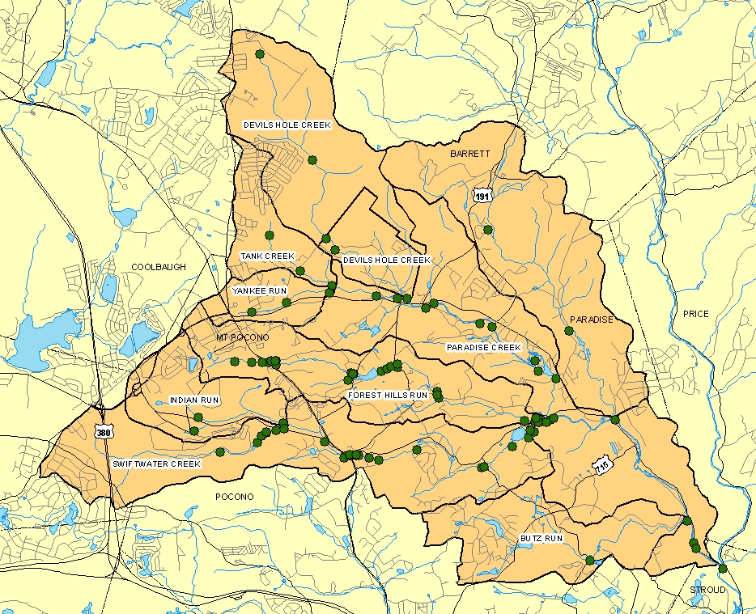

June 2003
Revised July 2003

Revised and Updated
October 2003

Prepared for:

Brodhead Watershed Association
c/o Mrs. Debra Brady
PO Box 339
Henryville, PA 18332

Prepared by:

Mr Brian Oram, Principle Investigator
Wilkes University
GeoEnvironmental Sciences and Engineering Department
84 West South Street
Wilkes Barre, PA 18766

Table of Contents

1.0 Introduction ………….……………………………………………………… 1
2.0 Source of Data ………………………………………………………………. 2
2.1 Data Correction ……………………………………………………… 4
2.2 Spatial Data and Manipulation ………………………………………. 4
2.2.1 Limitations of Existing Data ………………………………. 7
2.3 Data Available by Year and Season …………………………………. 8
3.0 Data Evaluation ……………………………………………………………… 12
3.1 Temperature …………………………………………………………. 13
3.2 Dissolved Oxygen …………………………………………………… 19
4.0 Water Quality for Specific Streams ………………………………………….. 22
4.1 Devils Hole Creek…………………………………………………….. 22
4.2 Forest Hills Run ……………………………………………………… 22
4.3 Swiftwater Creek ……………………………………………………. 23
4.4 Paradise Creek ……………………………………………………….. 24
5.0 Recommendations ……………………………………………………………. 25
5.1 Existing Data …………………………………………………………. 25
5.2 Additional Data ………………………………………………………. 26

ii
Listing of Tables

Table 1. Pennsylvania State's Water Quality Classification ……………………. 1
Table 2. Summary Look-Up Table for Compiled Datasets ………………………. 4
Table 3. Summary of Number of Sampling Events by Year …………………….. 9
Table 4. Number of Water Samples by Parameter for the Available Dataset ……. 12
Table 5. Temp1 Criteria for the Paradise Creek Watershed …………………….. 13
Table 6. Summary of Dissolved Oxygen Concentrations for the Paradise
Creek Watershed ……………………………………………………….. 21
Table 7. Summary of Water Quality Data for Forest Hills Run …………………. 23
Table 8. Summary of Water Quality Data for Swiftwater Creek ………………… 24
Table 9. Summary of Water Quality Data for Paradise Creek …………………… 25

Listing of Figures

Figure 1. Initial Watershed Map Showing Sample Sites, RCRA, STP, Hazard Sites
and Error in Gage Sites ………………………………………………… 6

Figure 2. Unverified and Verified Well and Spring Locations (unclipped data) … 7

Figure 3a. Number of Sampling Events for Yankee Run, Butz Run, Tank Creek
Devils Hole Creek, and Indian Run in the Paradise Creek Watershed …. 10

Figure 3b. Number of Sampling Sites for Forest Hills Run, Swiftwater Creek,
Cranberry Creek, and Paradise Creek …………………………………… 10

Figure 4. Number of Sampling Events by Quarter for Each Stream …………….. 11

Figure 5. Number of Data Records for Each Stream and Importance of
Volunteer Monitoring Program …………………………………………. 11

1.0 Introduction

A “data gap” analysis was conducted for the Paradise Creek Watershed. The Paradise Creek Watershed is a 44.5 square mile sub-watershed that is part of the Broadhead Watershed and within the Delaware River Basin. The Paradise Creek subwatershed lies within the following municipal jurisdictions: Barrett Township, Coolbaugh Township, Paradise Township, Pocono Township, Tobyhanna Township and Mount Pocono Borough within Monroe County, Pennsylvani. A “data gap” analysis is one component of conducting a watershed assessment and developing a watershed restoration and management plan. The streams comprising the Paradise Creek Watershed include Cranberry Creek, Devils Hole Creek, Tank Creek, Yankee Run, Forest Hills Run, Swiftwater Creek, Paradise Creek, and Butz Run. With the exception of the upper reaches of Devils Hole Creek, the streams are classified as high quality cold water fisheries. The upper reach of Devils Hole is classified as exceptional value water, see Table 1.

Table 1. Pennsylvania State’s Water Quality Classifications.
“EV = Exceptional Value Waters. Special Protection Status-a stream or watershed which constitutes an outstanding national, state, regional or local resource, such as waters of national, state, or county parks or forests, or waters which are used as a source of unfiltered potable water supply, or waters of wildlife refuges or State Game Lands, or waters which have been characterized by the PA Fish and Boat Commission as "Wilderness Trout Streams," and other waters of substantial recreational or ecological significance.

HQ = High Quality Waters. Special Protection Status- a stream or watershed which has excellent quality waters and environmental or other features that require special water quality protection.

CWF = Cold Water Fisheries. Maintenance and/or propagation of fish species including the family Salmonidae and additional flora and fauna which are indigenous to a cold water habitat. HQ-CWF criteria DO₆ (minimum DO 7.0 mg/l) and Temp_{1.}

A “data gap” analysis includes the following tasks: compiling a list of available water quality data, reviewing and evaluating spatial geographical data and water quality data, and developing specific recommendations regarding the existing data and data needs for the project.

2.0 Source of Data

The first component of this assessment was to determine the types and availability of water quality data for this watershed and to compile information related to sampling and testing methodology. In compiling the water quality data it was determined that a number of organizations, agencies, municipalities, and non-profit organizations have been collecting water quality data, since 1966. The following sources of water quality data were identified for the Paradise Creek Watershed.

United States Geological Survey (USGS)
Site Name: Paradise Creek at Henryville, PA
Period of Record: August 14, 1966 to July 23, 1980
Number of Records: 12
USGS Site Number: 01440500
Testing Parameters: (see Appendix A-1)

Monroe County Planning Commission (MC)
Streams: Forest Hills Run, Indian Run, Tank Creek, Yankee Run, Devils Hole Creek, Paradise Creek, Swiftwater Creek
Period of Record: 1990 to 2001 (3rd and 4th quarter of year)
Number of Events: 51 events at 27 sites
Testing Parameters: flow, temperature, dissolved oxygen, pH, conductivity, total hardness, alkalinity, nitrate+nitrite, ammonia, total phosphate, chlorides, total acidity, total dissolved solids, total suspended solids, fecal coliform, biochemical oxygen demand, and trace metals.

Mount Pocono Municipal Authority- (ITC)
Streams: Forest Hills Run
Period of Record: 1991 – 1994
Number of Events: 8 sites, 3 events, 18 samples
Testing Parameters: temperature, dissolved oxygen, percent saturation, pH, conductivity, total hardness, alkalinity, nitrate, ammonia, total
phosphate, chloride, BOD, TDS, TSS, TKN, orthophosphate

Paradise Township (PADTWP)
“Paradise Township Sediment, Soils and Water Sampling”, March 14, 2002.
Streams: Yankee Run, Tank Creek, Devils Hole Creek, Paradise Creek, Forest Hills Run
Number of Events: 1 event 5 sites
Period of Record: September to November 2001
Testing Parameters: pH, conductivity, hardness, alkalinity, nitrite, nitrate, ammonia, total phosphate, chloride, acidity, fecal coliform, BOD, TDS

Pennsylvania Department Of Environmental Protection (PADEP)
Streams: Swiftwater Creek and Forest Hills Run
Period of Record: Swiftwater (1992, 1997, 2000); Forest Hills Run (1993,1997,1999, 2000)
Number of Events: Swiftwater 13 samples and 8 stations; Forest Hills Run
22 samples and 8 stations)
Testing Parameters: temperature, dissolved oxygen, percent saturation, pH, conductivity, total hardness, alkalinity, nitrate, ammonia, total
phosphate, chloride, BOD, TDS, TSS, TKN, orthophosphate

2

Aventis Pastuer Inc. (RMC)
Streams: Swiftwater Creek
Period of Record: 1992- 2000
Number of Events: 26 events, 3 stations, 78 samples
Testing Parameters: temperature, cfs, dissolved oxygen, percent saturation, pH, conductivity, alkalinity, nitrate, ammonia, total
phosphate, chloride, fecal coliform, BOD, COD, chloride, TDS, TKN, copper, zinc, aluminum, mercury

Brodhead Watershed Association (BWA)
Streams: Butz Run, Cranberry Creek, Devils Hole Creek, Forest Hills Run, Indian Run, Paradise Creek, Swiftwater Creek, Tank Creek, Yankee Run
Period of Record: 1980 – 2002
Number of Events: 33 stations, 1831 samples
Testing Parameters: Field testing only (temperature, pH, nitrate, and orthophosphate). Additional data is also available. The additional data was Paradise Township data from a testing program in the 1980s. The data was reportedly entered into the Storet database by BWA. and entered into Storet. The samples were collected by BWA and tested by Prossers Laboratory.

THE ALLIANCE FOR AQUATIC RESOURCE MONITORING (ALLARM)
Status: Inactive – 7 Sites in Monroe County
Streams: Brodhead Creek, Lake Naomi, Lehigh River, McMichaels Creek, Paradise Creek, Rocky Run, Tobyhanna Creek
Data: Available data is included into the BWA data. The data appears to be limited to pH, temperature, and alkalinity.

As part of compiling the available water quality data, a comprehensive lookup table was created, see Table 2. The lookup table provided a means of identifying stations by a unique station identification number and brief description of the sampling station, indicated the source of the data, and provided the estimated global position for the site. The global position for the sites were based on information provided in the project reports or positional data provided by the Monroe County Planning Commission and Mrs. Debra Brady. In some cases, the reports provided no positional data other than a map or sketch of the sampling locations. When positional data was provided within a report, there were a number of sampling sites that did not map within 100 feet of the stream. In these cases, the site locations were based on the description provided in the report and follow-up field confirmation by Mr. Brian Oram using a hand-held GPS. The field readings were confirmed and verified using online mapping tools, such as Topozone.com.

3
Table 2. Summary Look-Up Table for Compiled Datasets.

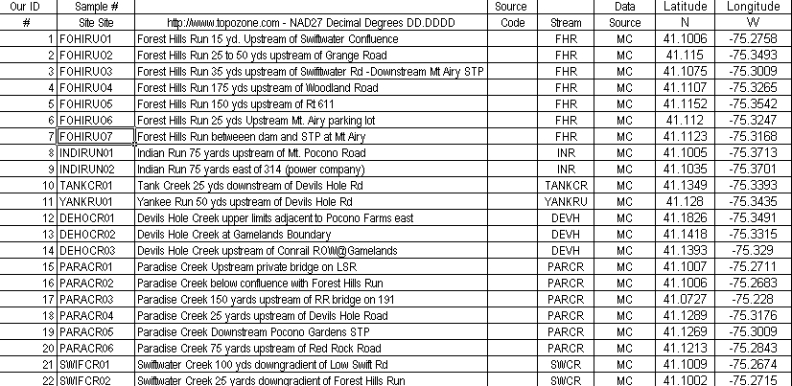

In addition to the datasets previously identified, it is likely that additional water quality data is available from other municipalities, consultants, private citizens, government agencies, and other non-profit organizations for this watershed. As the project progresses, these resources should be identified, and the information obtained should be integrated into the growing data resource for the watershed.

2.1 Data Correction

As part of compiling the available data, the following corrections and changes were conducted:
1) greater than and less than signs were removed and replaced with method detection limits,

2) removed ?, O, and na (not available) and replaced with either a detection limit or a blank field,

3) corrected errors in the sampling date and year, and

4) sample site positions were corrected and in a few cases field verified.

2.2 Spatial Data and Manipulation

The following types of spatial data were available for this project:
Monroe County Data CD
springs_monroe.shp, waterfeats4.shp, waterbodies.shp, monroe.shp, mgmtareasf.shp, and muni.shp

4
Minimal data manipulation was required for these data layers, but there were questions related to the actual watershed boundary. Further, the attribute table lacked the watershed characteristics for the Cranberry Creek subwatershed. These issues were going to be addressed by the USGS, Borton-Lawson Engineering Inc., and the Monroe County Conservation District.

Wilkes University
Sampling Sites
samp_sites_paradise2.shp

The original data was in the Excel spreadsheet entitled oramstream1jen.xls. The spreadsheet was edited into a format suitable for saving as a database file (.dbf). The .dbf file was saved as samp_sites_paradise2 and was brought into ArcMap as x,y data. ArcMap then overlaid the data using the latitude and longitude coordinates provided in Table 2. The x,y data was then converted into a shapefile and the sites were symbolized into categories based on the DATA column in the attribute table. The sampling sites were labeled on the map using the ID attribute. Following the initial projection, a number of sampling site locations required confirmation and correction. The ALLARM site was added to the sampling site shapefile by adding the original ALLARM data into the map, editing the sampling sites shapefile, and creating a new sampling site.

Sewage Treatment/Hazard Facilities (Figure 1)
stp_new_paradise.shp

The original data was compiled into an Excel spreadsheet entitled otherwastedischarges.xls by Mr. Brian Oram. The spreadsheet was edited into a format suitable for saving as a database file. The .dbf file was saved as stp_new_paradise and was brought into ArcMap as x,y data. ArcMap then overlaid the data using the latitude and longitude coordinates provided in PADEP reports or online databases, i.e., EnviroMapper. In some cases the positional data required correction and field confirmation. The x,y data was then converted into a shapefile, and the points were labeled on the map using the SITE attribute.
USGS Gage Station (Figure 1)
USGS_gage.shp

The original data was in the Excel spreadsheet entitled USGS.xls. This spreadsheet was based on data originally available as part of the BASINS Database. Because of errors in the BASINS database, Better
5
Assessment Science Integrating Point and Nonpoint Sources, the actual positions were corrected using information available from the USGS. The spreadsheet was edited into a format suitable for saving as a database file. The .dbf file was saved as USGS_guage and was brought into ArcMap as x,y data. ArcMap then overlaid the data based on the latitude and longitude coordinates. The x,y data was then converted into a shapefile.
Dams/Impoundments
dams_paradise.shp

The original data was in the Excel spreadsheet entitled dams.xls. This spreadsheet was based on data available as part of the BASINS Database. Because of errors in the BASINS data related to position, the actual positions were corrected using information available from the USGS, previously sited reports, and available topographic maps. The spreadsheet was edited into a format suitable for saving as a database file. The .dbf file was saved as dams_paradise.dbf and brought into ArcMap as x,y data. ArcMap was then used to overlay the data using the available position data. The x,y data was then converted into a shapefile.

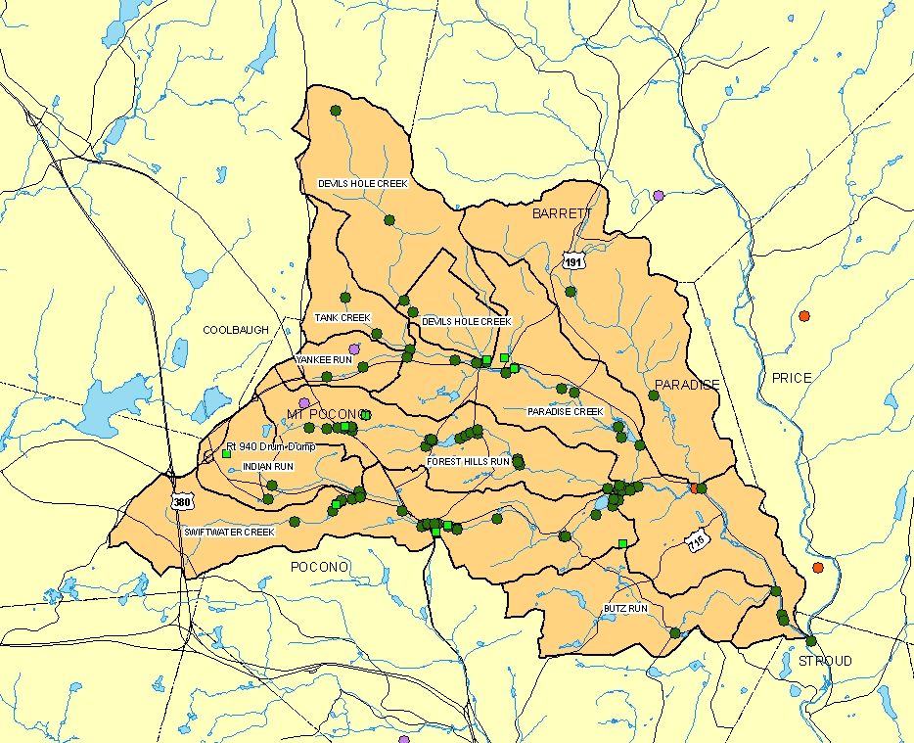 | 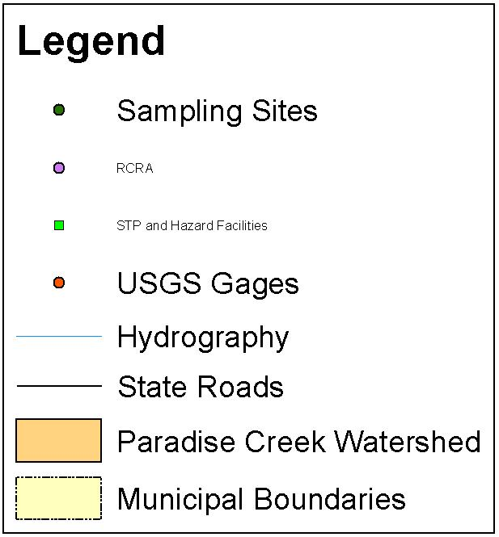  Figure 1. Initial Watershed Map Showing Sample Sites, RCRA, STP, Hazard Sites, and Error in Gage Sites.

6
PAGIS Well Data Files (Figure 2)

The Commonwealth of Pennsylvania Department of Conservation and Natural Resources Bureau of Topographic and Geological Survey has developed a number of Access database files related to the location, construction detail, yield, and general quality for wells and springs throughout the Commonwealth of Pennsylvania. The data is divided into verified, i.e., Fvwells.dbf, Springs.dbf, and Qwdata.dbf, and unverified data, i.e., WWI.dbf. Before using the data in ArcMapper, the spatial data needed to be reprojected. The metadata files for this dataset provided the necessary information to reproject files into a suitable GIS format. Following the initial technical team meeting, December 11, 2002, Mr. Paul DeBarry of Borton-Lawson Engineering, Inc. indicated that a corrected water resource map for the watershed was available. In the future, it would be advisable to include the well dataset into the Paradise Creek Watershed, but a number of sites should be randomly checked and field verified.

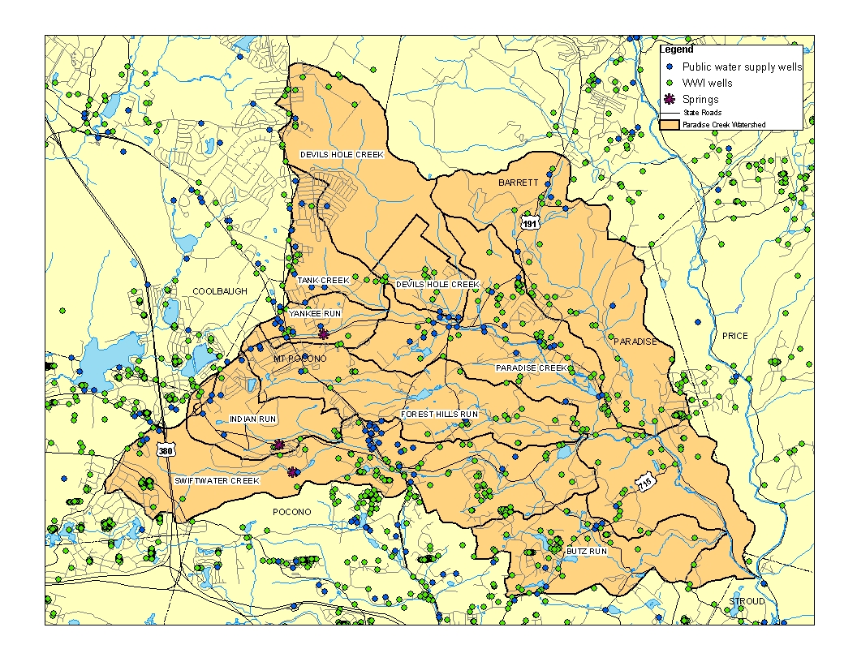

Figure 2. Unverified and Verified Well and Spring
Locations (unclipped data).

2.2.1 Limitations of Existing Data
The primary limitation with many of the aforementioned datasets was the lack of metadata files. Metadata files are basically data about the quality, accuracy, and way the data was collected, compiled, processed,

7

projected, maintained, and updated. It is critical to obtain and establish metadata files for all database files and develop metadata files for all new data.

The BASINS version 2.0, Better Assessment Science Integrating Point and Nonpoint Sources, contained a number of different datasets that may be applicable to this project. These datasets include:

bc_stat.dbf Bacteria Monitoring Summary Data
dam.dbf Dam Locations
(cu).dbf Digital Elevation Model
dws.dbf Drinking Water Supply Sites
gage.dbf Gage Sites
ifd.dbf Industrial Facilities Discharge
lulcndx.dbf Land-Use / Land Cover (1980)
fhards.dbf Major Roads
nsi.dbf National Sediment Inventory
ppl.dbf Populated Place Locations
rcris.dbf Resource Conservation and Recovery
st.dbf State Boundaries
cnty.dbf County Boundaries
cerclis.dbf Superfund National Priority List
stasgo.dbf State Soil and Geographic Database
tri.dbf Toxic Release Inventory
urban.dbf Urban Areas
wq_stat.dbf Water Quality Monitoring Stations &
Data
wqobs.dbf Water Quality Stations and
Observations
wdm.dbf Weather Data Stations & Database
met_stat.dbf Weather Data Stations

Attempts were made to use the rcris.dbf, tri.dbf, dam.dbf, dws.dbf, dam.dbf, gage.dbf, lulcndx.dbf, and datasets related to water quality data, but it was determined that there were many positional and projection errors that limited the use of this data. Because of the number of errors and incomplete information, it was determined that the BASINS dataset may contain valuable information, but would require a significant amount of post-processing, correction, and manipulation.

2.3 Data Available by Year and Season
For the period from 1966 – 2002, the compiled dataset provides a record of over 2000 sampling events for the Paradise Creek Watershed. Because of the limited data prior to 1985, the data analysis was limited to the period from 1985 to 2002. Table 3 is a summary of the number of samples collected in the Paradise Creek Watershed. Table 3 indicates that the monitoring efforts appear to have peaked in the early to mid

8
1990s and have been gradually decreasing over time. Figure 3a and Figure 3b are graphical representations of the sampling frequency data for each tributary. From Figure 3a, it appears that there is limited data for the smaller subwatersheds of the Paradise Creek Watershed prior to 1991. Figure 4 is a graphical representation of the number of sampling events by season for the tributaries and main stem of the Paradise Creek Watershed. With the exception of Forest Hills Run, Paradise Creek, and Swiftwater Creek, there appears to be a nearly balanced quarterly monitoring program. This graph is actually very misleading because most of the water quality data related to dissolved oxygen, nutrients, sediment load, bacteria and trace metals are typically only available for the 3rd Quarter of the year. The reasons why the data appears seasonally balanced include: Brodhead Watershed Association has a very consistent monthly monitoring program and Forest Hills Run, Paradise Creek, and Swiftwater Creek have the longest main stems and have received additional monitoring because of conservation measures and the location of permitted discharges.

Table 3. Summary of Number of
Sampling Events by Year.
Year | Events
1985 | 11
1986 | 2
1987 | 2
1988 | 7
1989 | 2
1990 | 9
1991 | 151
1992 | 278
1993 | 255
1994 | 206
1995 | 172
1996 | 191
1997 | 204
1998 | 150
1999 | 93
2000 | 127
2001 | 121
2002 | 76

9
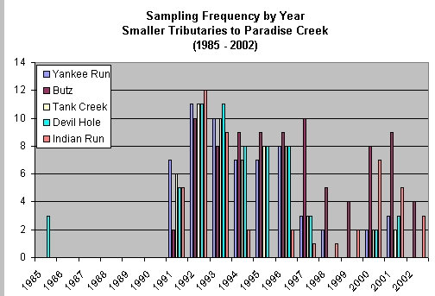

Figure 3a- Number of Sampling Events for Yankee Run, Butz Run,
Tank Creek, Devils Hole Creek, and Indian Run in the Paradise Creek Watershed.

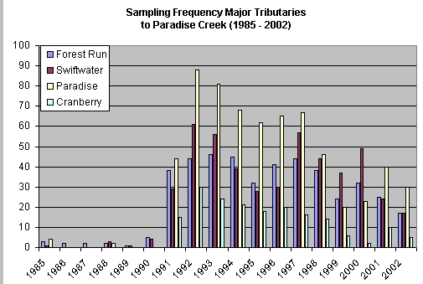

Figure 3b. Number of Sampling Events for Forest Hills Run, Swiftwater Creek, Cranberry Creek and Paradise Creek.

10
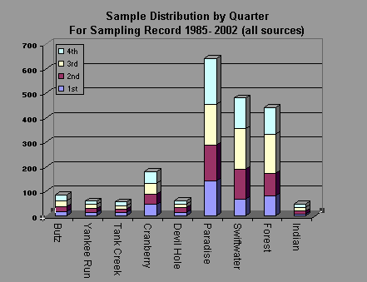

Figure 4. Number of Sampling Events by Quarter for Each Stream.

Figure 5 represents the number of sampling events, i.e., records, for each stream in the subwatershed. Because of the efforts of the Brodhead Watershed Association (BWA), there is a significant increase in the amount of background data available for this assessment. If it were not for the efforts of the BWA, there would be no data for Butz Run, Cranberry Creek, and Tank Creek.

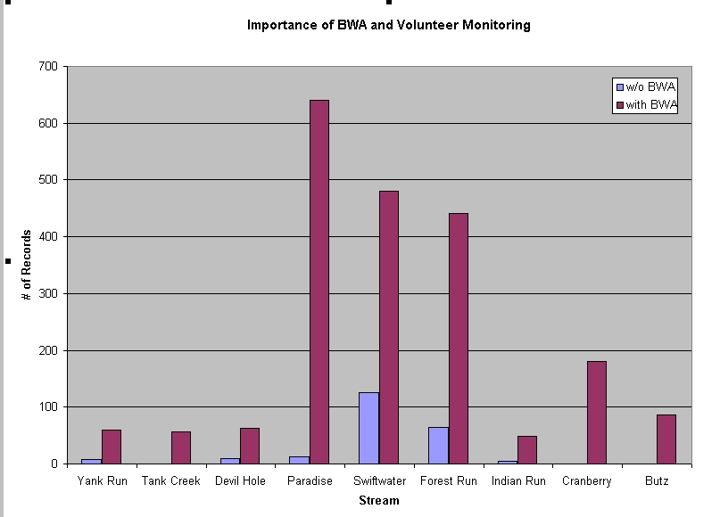

Figure 5. Number of Data Records for Each Stream and Importance of Volunteer Monitoring Program.

11
3.0 Data Evaluation

Table 4 shows the number of sampling events for each water quality parameter. The data gap evaluation concentrated on the following water quality parameters: temperature, pH, dissolved oxygen, nitrate, ammonia, and total phosphorous. As part of this evaluation, the stream water quality was compared to the standards provided by the “PA WATER QUALITY STANDARDS”, see Appendix A-2.

Table 4. Number of Water Samples by Parameter
for the Available Dataset.
12
Parameter | # samples
Temperature | 1981
DO | 205
% DO | 205
pH(f) | 2008
conductivity (f) | 223
T.Hardness | 135
T. Alkalinity | 254
Nitrite (N) | 192
Nitrate (N) | 230
Ammonia (N) | 230
T. Phosphate | 226
Orthophosphate | 3
T. Kjeldahl (N) | 97
Chloride | 230
Acidity | 105
Fecal Coliform | 186
BOD | 230
TDS | 181
TSS | 118
T. Aluminum | 108
D. Aluminum | 99
Fecal Streptococcus | 26
T. Chlorine | 3
Cadmium | 15
Chromium | 18
Copper | 96
Iron | 18
Lead | 96
Manganese | 18
Nickel | 18
Zinc | 96
redox potential | 14
TOC | 3
T. Cyanide | 2
F. Cyanide | 2
Mercury | 81
COD | 81
CBOD | 80

3.1 Temperature

Temperature is a critical water quality and environmental parameter because it governs the kinds and types of aquatic life, regulates the maximum dissolved oxygen concentration of the water, and influences the rate of chemical and biological reactions. The organisms within the ecosystem have preferred temperature regimes that change as a function of season, organism age or life stage, and other environmental factors. With respect to chemical and biological reactions, the higher the water temperature the higher the rate of chemical and metabolic reactions.
Seasonal variations in stream temperature may be caused by changing air temperature, solar angle, meteorological events, and a number of physical aspects related to the stream and watershed. These physical features include stream origin, velocity, vegetation types and coverages, stream configuration, land-use, and percentage of impervious area. For example, a narrow, deep well-shaded shoreline reduces the impact of warming by the sun; whereas, a wide shallow stream would be more impacted by solar heating.

Regarding temperature, the streams within the Paradise Creek Watershed are regulated under the maximum temperature criteria, Temp1. Table 5 provides a summary of the temperature criteria for the Paradise Creek Watershed and Appendix A-2 provides a more detailed description of the stream classification criteria.

Table 5. Temp1 Criteria for the Paradise Creek Watershed.

Period Temp°F Period Temp°F
Jan 1-31 38 July 1-31 66
Feb 1-29 38 August 1-31 66
Mar 1-31 42 September 1-15 64
Apr 1-15 48 September 16-30 60
Apr 16-30 52 October 1-15 54
May 1-15 54 October 16-31 50
May 16-31 58 November 1-15 46
June 1-15 60 November 16-30 42
June 16-30 64 December 1-31 40

3.1.1 Stream Sites in Paradise Creek

Because of the large number of data points related to stream temperature, the temperature data for each subwatershed was evaluated. Comparing the measured temperature to the regulated temperature and

13
then graphing the degrees above or below the regulated temperature completed the graphical data evaluation. Regarding the interpretation of the temperature graphs, the data that plots above 0 degrees would be out of compliance or non-compliant and the data the plotted below 0 degrees would be classified as compliant. The temperature data was evaluated using a spreadsheet evaluation method that was developed by Dr. Robert Traver at Villanova University.

Butz Run (Temperature Range 1 to 25 C)
Elevated temperature reported on April 30, 1993(+13.89 C), July 20, 1994 (+5.11 C) and June 27, 1999 (+7.22 C). The three events are for the same sampling site, i.e., BWA Code 238, Sampling Site 50, BUTZCRO1 (BUTZ RUN at Paradise Creek confluence). There does not appear to be any trends that suggest increasing stream temperatures with time.

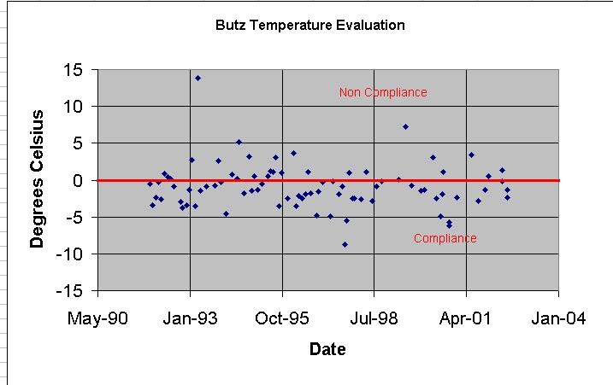

Site ID # | Sample Site | Site | Site
 | Number | Description | Code
50 | BUTZCR01 | BUTZ RUN (at Paradise Creek confluence) | BWA 238

14

Cranberry Creek (Temperature Range 1 to 24 C)
A few elevated temperatures reported on February 23,1993
(+8.67 C- Site ID 47) and June 27, 1999 (+6.2 C- Site ID 49).
The stream appears to represent a relatively unimpacted watershed with minimal temperature variation over time.

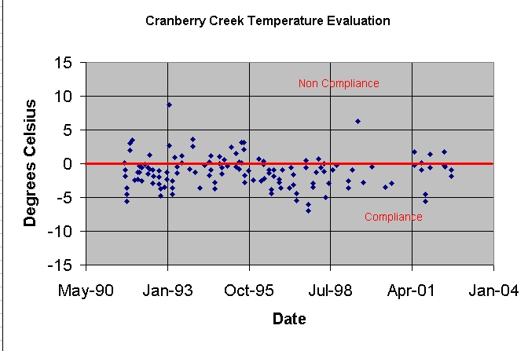

Site ID # | Sample Site |  | Site
 | Number | Description | Code
47 | CRANCR01 | CRANBERRY CREEK (in Cranberry Estates) | BWA 235
49 | CRANCR03 | CRANBERRY CREEK (at Paradise Creek Confluence) | BWA 237

Devils Hole Creek (Temperature Range 2 to 16.5 C)
Stream appears to represent a relatively unimpacted watershed with minimal temperature variation over time.
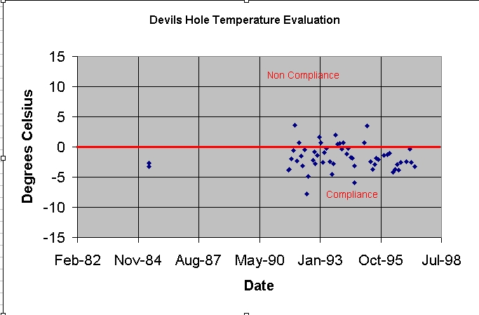

15

Forest Hills Run (Temperature Range 1 to 28 C)
There appears to be a wider spread in temperature variation and increase in number of incidences not in compliance. There does not appear to be a trend in the data that suggests a long-term increase in stream temperature, but there are a significant number of data points in the non-compliance region of the graph. The following is a listing of sites that have reported temperature values 5 C higher then the compliance level.

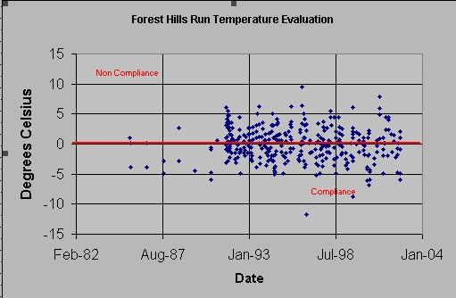

Site ID # | Sample Site | Site | Site
 | Number | Description | Code
43 | FOHIRUO9 | FOREST HILLS RUN (at Swiftwater confluence) | BWA 231
61 | FOHIRU10 | FOREST HILLS RUN (at Red Rock Rd. bridge) | BWA 246
62 | FOHIRU11 | FOREST HILLS RUN - at Carlton Rd. bridge | BWA 247
64 | FOHIRU13 | FOREST HILLS RUN (at Grange Rd. bridge) | BWA 248
66 | FOHIRU15 | FOREST HILLS RUN Upstream Main Parking Lot | PADEP
67 | FOHIRU16 | FOREST HILLS RUN Upstream Mt Airy STP Discharge | PADEP
68 | FOHIRU17 | FOREST HILLS RUN immediately upstream Mtn Airy STP | PADEP
78 | FOHIRU27 | FOREST HILLS RUN 3000 feet downstream Rt 611 | ITC

16
Indian Run (Temperature Range 2 to 23 C)
Stream appears to represent a relatively unimpacted watershed with minimal temperature variation over time.

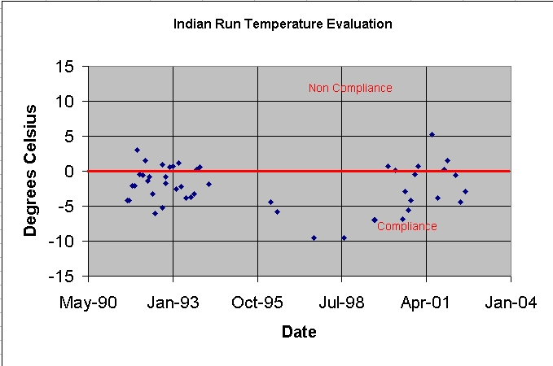

Site ID # | Sample Site | Site | Site
 | Number | Description | Code
33 | INDIRUN03 | INDIAN RUN (at Swiftwater Creek confluence) | BWA 225

Paradise Creek (Temperature Range 0.5 to 30 C)
During the period from 1993 to 2002, there were approximately 11 incidences of elevated temperature, i.e., greater than +5 C above compliance level. There does not appear to be a trend in the data that suggests a long-term increase in stream temperature. Based on the available data, it appears that some of the elevated temperatures may be related to local discharges the lake and a fish hatchery.

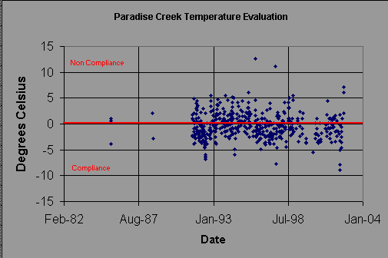

Site ID # | Sample Site | Site | Site
 | Number | Description | Code
45 | PARACR09 | PARADISE CREEK (above Rt. 191 tunnel) | BWA 233
52 | PARACR10 | PARADISE CREEK (at PFLA lake spillway) | BWA 239
53 | PARACR11 | PARADISE CREEK (above PFLA lake) | BWA 240
54 | PARACR12 | PARADISE TRIBUTARY (receives some flow from hatchery) | BWA 240A
55 | PARACR13 | PARADISE TRIBUTARY from hatchery | BWA 240 B

17
Swiftwater Creek (Temperature Range 1 to 25 C).
During the period of record, there were only 3 incidences of elevated temperature, i.e., greater than +5 C. There does not appear to be trend in the data that suggests a long-term increase in stream temperature and it appears that two of the elevated temperatures may be associated with discharge from a lake.

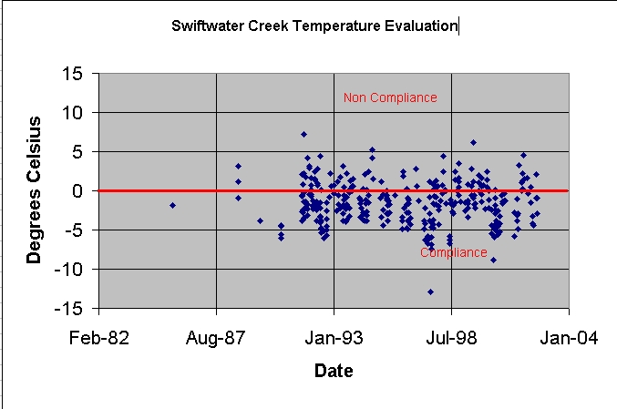

Site ID # | Sample Site | Site | Site
 | Number | Description | Code
36 | SWIFCR09 | SWIFTWATER CREEK (at Brosius power line)/Bowman Camp | BWA 228
41 | SWIFCR14 | SWIFTWATER CREEK (on lake spillway)/HULBERT HILL ROAD BRIDGE | BWA 230

Tank Creek (Temperature Range 2 to 19 C)
Stream appears to represent a relatively unimpacted watershed with an insignificant temperature variation over time.

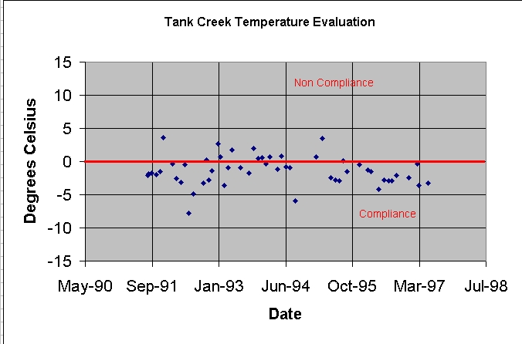

18

Yankee Run (Temperature Range 1 to 19.2 C)
Stream appears to represent a relatively unimpacted watershed with an insignificant temperature variation over time.

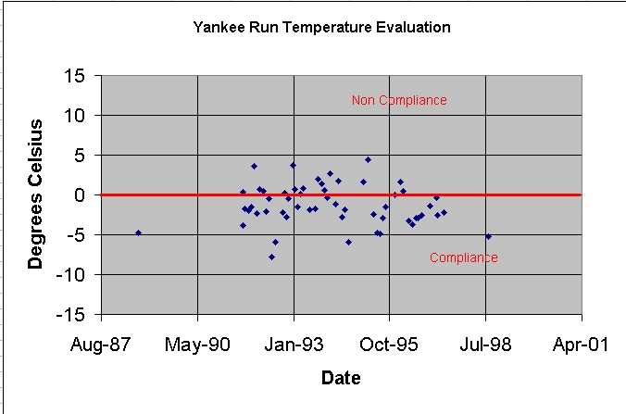

From a watershed perspective, there does not appear to be systematic temperature changes that would indicate a long-term problem with increasing water temperature or waters that would not meet the criteria for a cold-water fishery. The available data suggests that Paradise Creek and Forest Hills Run are experiencing the greatest temperature variations. It is not clear the cause of the temperature variations from a watershed perspective, but it is likely associated with changes in watershed characteristics, presence of permitted discharges, and proximity to urban/developed areas. From the specific sampling data, it appears that some of the warmer water temperature effects may be associated with discharges from shallow lakes and ponds and local discharges. It is also possible that urban runoff
deforestation/encroachment into the riparian zone, and possible
direct stormwater discharge may account for some of the temperature variation.

3.2 Dissolved Oxygen

Dissolved oxygen in a stream may vary from 0 mg/l to 18 mg/l. Readings above 18 mg/l are physically impossible and would represent errors in calibration, operation, and/or data recording. Dissolved oxygen gets into the water by diffusion from the atmosphere, aeration of the water as it moves through falls and rapids, and as a by-product of photosynthesis. The amount of dissolved oxygen in the stream is a function of water temperature, chemical and biological reactions,

19

reaeration and oxygen consumption. Oxygen demand by the aquatic organism depends upon the type and species of aquatic organism, temperature of the water, water quality, and the life stage of the organism.

Reduced dissolved oxygen levels in a stream may be due to an increase in water temperature, organic load, fish production, primary productivity, and/or bacterial activity. Another reason for decreased dissolved oxygen may be increases in stream fertility associated with nutrient influx from urban, rural, and industrial areas. The same fertilizer, which is used to stimulate plant growth on land, accelerates the growth of aquatic micro- and macroscopic plants. During the day, photosynthesis will increase dissolved oxygen levels, but in the evening respiration and decomposition of organic debris would result in decreased dissolved oxygen levels. Dissolved oxygen levels rise from morning through the afternoon as a result of photosynthesis, reaching a peak in late afternoon. Photosynthesis stops at night, but plants and animals continue to respire and consume oxygen. As a result, dissolved oxygen levels fall to a minimum just before dawn. This process can result in large daily fluctuations in dissolved oxygen that are characteristic of bodies of water with extensive plant growth, fish kills, and internal nutrient cycling.

The generally accepted minimum amount of dissolved oxygen that will support a fish population is from 4 to 5 mg/l. When the dissolved oxygen level drops below 3 mg/l, even hardy fish species will die. It is important to remember that there may be sufficient dissolved oxygen to maintain life, but the oxygen level may be too low to sustain reproduction, development, and function of the organisms. As an example, a trout needs five to six times more dissolved oxygen when the water temperature is at 24º C (75º F) as compared to when the water temperature is 4º C (41º F). This is because the metabolic rate of the organism increases as the water temperature increases.

Depletion in dissolved oxygen or rapid changes in dissolved oxygen level will also cause major shifts in the kinds of aquatic organisms present in the ecosystem. Species that cannot tolerate low levels of dissolved oxygen include: mayfly nymphs, stonefly nymphs, and beetle larvae. Over time, more pollution-tolerant organisms, such as worms and fly larvae, could replace these organisms. Nuisance algae and

20
anaerobic organisms, i.e., organisms that live without oxygen, may also become abundant in waters with low levels of dissolved oxygen.

Based on the stream classification, the specific water quality criteria for dissolved oxygen (DO6) is 7 mg/L for the streams within the Paradise Creek Watershed. Based on the available data, the only stream with reported dissolved oxygen concentrations < 7 mg/L is Forest Hills Run. It is possible that more sites and streams within the watershed may experience diurnal fluctuations in dissolved oxygen conditions, but this data does not appear to be available. To address this lack of information, it would be advisable to consider the use of continuous water quality monitoring or event based continuous monitoring at selected sites within the watershed, see Table 6.

Table 6. Summary of Dissolved Oxygen Concentrations
for the Paradise Creek Watershed.

 | Lowest Reading | Highest Reading | DO < 7 | Number
 | mg/L | mg/L | mg/L | of Sampling Events
Butz | no data | no data | no data | 0
Cranberry | no data | no data | no data | 0
Devils Hole | 10.2 | 11.8 | 0 | 5
Forest Hills | 5.5 | 13.2 | 5 | 62
Indian Run | 8.4 | 10.1 | 0 | 4
Paradise | 7.2 | 10.2 | 0 | 8
Swiftwater | 7.2 | 19.7* | 0 | 121
Tank Creek | 8.5 | 10.25 | 0 | 3
Yankee Run | 9.2 | 9.2 | 0 | 1

*Note: Dissolved oxygen concentrations greater than 18 mg/L is unlikely and represents an error in the field instrument, calibration, and recording and the result should be checked or invalidated.

21
4.0 Water Quality for Specific Streams

The following evaluation highlights specific observations and notations regarding water quality for the various subwatersheds. During this evaluation, the following criterion was used to evaluate the data. The graphical analysis can be found in Appendix A-3 of this report (Source: Specific Water Quality Criteria (Chapter 93 Regulations).

Alkalinity (ALK1) > 20 mg CaCO3/L
Fecal Coliform (BAC1) < 200 colonies/100 ml
Total Dissolved Solids (TDS1) < 500 mg/L
pH (pH1) 6.0 – 9.0
Nitrate (N) < 1 mg/L (not regulatory)
Ammonia – NH4-N (Am) < 0.05 mg/L (estimated from
regulations)
Biochemical Oxygen Demand 1 to 2 mg/L Very Clean
3 to 5 mg/L Mod. Clean
over 5 mg/L Serious Pollution
T. Phosphate < 0.1 mg P/L

4.1 Devils Hole Creel

Based on the available data, the fecal coliform concentrations ranged from 10 to 360 colonies/100 ml and there was one sample that exceeded 200 colonies/ 100 ml. Regarding total alkalinity, a total of 6 water samples were collected. The alkalinity ranged from 1 to 6 mg CaCO3/L
and all six samples were less than 20 mg CaCO3/L. The stream appears to have a very pristine water quality, but the low alkalinity indicates that the stream may be vulnerable to rapid changes in pH, increased metals loading, and decreasing biodiversity.

4.2 Forest Hills Run

Table 7 is a summary of the available data related to Forest Hills Run. Total phosphate data ranged from 0.01 to 12.8 mg P/L, with 38 samples of 64 samples or 59 % exceeding 0.1 mg P/L. The historical data indicates that Forest Hills Run is being impacted. From the available data, it is apparent that Forest Hills Run has and may still be experiencing problems associated with low alkalinity and elevated nitrates, fecal coliform, biochemical oxygen demand, total dissolved solids, total phosphate and total aluminum. The extent of the impact has not been clearly defined, but it appears to be a combination of activities related to increased fecal coliform, nutrient loading, dissolved solids, and BOD of the water.

22
Table 7. Summary of Water Quality Data for Forest Hills Run.

Parameter | Range of Results | Number Exceeding  Limit | Limit of Parameter
Alkalinity | 7 – 94 mgCaCO3/L | 13 of 61 or 21% | < 20 mg CaCO3/L
pH | 6 – 8.9 | 0 of 436 or 0% | 6.0 – 9.0
Fecal Coliform | 10 – 8000  colonies/100 ml | 15 of 43 or 35% | > 200 colonies/100 ml
BOD5 | 0.05 – 210 mg/L | 33 of 65 or 51% | > 1 mg/L
 | 0.05 – 210 mg/L | 19 of 65 or 29% | > 2 mg/L
 | 0.05 – 210 mg/L | 10 of 65 or 15% | > 5 mg/L
Total Dissolved  Solids | 4 to 1268 mg/L | 3 of 38 or 8% | > 250 mg/L
T. Aluminum | 0.036 – 0.2 mg/L | 11 of 14 or 78% | > 0.1 mg/L
Nitrate | 0.05 – 7.74 mg N/L | 20 of 125 or 16% | > 1 mg/L
Nitrite | 0.002 – 1.06 mg N/L | 1 of 53 or 2 % | > 1 mg/L
Ammonia | 0.01 – 9.96 mg N/L | 42 of 64 or 65 % | calculated 0.05 mg N/L

4.3 Swiftwater Creek

Based on the available data, the fecal coliform concentrations ranged from 1 to 3000 colonies/100 ml and there were two samples that exceeded 200-colonies/ 100 ml (8/18/1994) and one sample over 2000 colonies per 100 ml (8/12/1998). Total phosphate data ranged from 0.01 to
0.126 mg P/L, with 3 % of the samples exceeding 0.1 mg P/L. The data indicates that the total phosphate concentration for Swiftwater Creek is increasing with time. Regarding total alkalinity, a total of 152 water samples were collected. The alkalinity ranged from 6.9 to 24.2 mg CaCO3/L and a total of 121 samples or 97 % were less than 20 mg CaCO3/L. Regarding pH, the pH ranged from 5.63 to 9.19 and only two samples were outside of the range of 6.0 to 9.0. Regarding the pH and alkalinity data, the data suggests that there may be a slowly decreasing alkalinity over time. If this is occurring, it would mean that Swiftwater Creek could become more susceptible to rapid changes in pH, increased metals loading, and decreasing biodiversity.

23

Table 8. Summary of Water Quality Data for Swiftwater Creek.

Parameter | Range of Results | Number Exceeding  Limit | Limit of Parameter
Alkalinity | 6.9 – 24.2 mg CaCO3/L | 121 of 125 or 97% | < 20 mg CaCO3/L
pH | 5.63 – 9.19 | 2 of 466 or <1% | 6.0 – 9.0
Fecal Coliform | 1 – 3000  colonies/100 ml | 3 of 103 or 3 % | > 200 colonies/100 ml
BOD5 | 0.2 – 4.30 mg/L | 56 of 65 or 86% | > 1 mg/L
 | 0.2 – 4.30 mg/L | 11 of 65 or 17% | > 2 mg/L
 | 0.2 – 4.30 mg/L | 0 of 65 or 0% | > 5 mg/L
Total Dissolved  Solids | 1 to 118 mg/L | 0 of 115 or 0% | > 250 mg/L
T. Aluminum | 0.019 – 0.2 mg/L | 23 of 91 or 25% | > 0.1 mg/L
Nitrate | 0.032 – 1.52 mg N/L | 2 of 124 or 1.6% | > 1 mg/L
Nitrite | 0.002 – 0.418 mg N/L | 0 of 98 or 2 % | > 1 mg/L
Ammonia | 0.01 – 0.24 mg N/L | 18 of 125 or 14 % | calculated 0.05 mg N/L

4.4 Paradise Creek
Total phosphate data ranged from 0.03 to 0.5 mg P/L, with 4 samples of 13 samples or 30 % exceeding 0.1 mg P/L. The available data does not appear to show a trend suggesting an increasing concentration of phosphate with time. The nitrate+nitrite concentration ranged from 0.18 to 10.5 mg N/L with 7% of the samples exceeding 1 and 10 mg N/L. It appears that the elevated nitrogen was associated with a specific event that occurred on or about September 1, 1988. Based on the available data, the fecal coliform concentrations ranged from 10 to 280 colonies/100 ml and there were two samples at or exceeding a concentration of 200-colonies/ 100 ml (6/26/2000 and 7/15/2001). The alkalinity ranged from 5 to 20 mg CaCO3/L and a total of 13 samples or 93 % were less than 20 mg CaCO3/L. The BOD5 ranged from 0.2 to 3 mg/L, with one sampling event exceeding a concentration of 1 mg/L. During this same sampling event, the reported dissolved oxygen and ammonia concentration was 7.2 mg/L and 0.08 mg NH4-N/L, respectively. From the available data, there does not appear to be any systematic changes in the water quality for Paradise Creek. The low alkalinity suggests the potential for decreasing water pH over time. The observed water quality problems in Paradise Creek appear to be event related and not reflective of long-term changes in water quality.

24
Table 9. Summary of Water Quality Data for Paradise Creek.
Parameter | Range of Results | Number Exceeding  Limit | Limit of Parameter
Alkalinity | 5 – 20 mgCaCO3/L | 12 of 13 or 92% | < 20 mg CaCO3/L
pH | 4.2 – 8.59 | 3 of 627 or < 1% | 6.0 – 9.0
Fecal Coliform | 10 – 280  colonies/100 ml | 1 of 13 or 7% | > 200 colonies/100 ml
BOD5 | 0.2 – 3 mg/L | 1 of 13 or 7% | > 1 mg/L
 | 0.2 – 3 mg/L | 1 of 13 or 7% | > 2 mg/L
 | 0.2 – 3 mg/L | 0 of 13 or 0% | > 5 mg/L
Total Dissolved  Solids | 34 to 61.7 mg/L | 0 of 6 or 0% | > 250 mg/L
T. Aluminum | 0.03 – 0.09 mg/L | 0 of 2 or 0% | > 0.1 mg/L
Nitrate | 0.14 – 10.5 mg N/L | 1 of 13 or 7% | > 1 mg/L
Nitrite | 0.002 – 0.1 mg N/L | 0 of 13 or 0 % | > 1 mg/L
Ammonia | 0.02 – 0.1 mg N/L | 2 of 13 or 15 % | calculated 0.05 mg N/L

5.0 Recommendations
The following are the recommendations for this project. The following recommendations are based on a review of the available data and the long-term objectives of the Paradise Creek Watershed Assessment.

5.1 Existing Data

With respect to the existing data files, a number of items should be integrated in the developing database for the project. These items are as listed.
1) Available GIS data should be compiled from the various regulatory agencies. This information should include: soils, land-use, LUST (leak fuel tanks), underground fuel tanks, hazardous facilities and small waste generators, regulated and unregulated water wells, geothermal wells, zoning, and other water quality data.

2) Additional historical data from BWA should be integrated into the background database. This data can be found in the attached data disk for this project. This data was not integrated into the summary lookup table because of the lack of information regarding sample site location and methods used for analysis.

3) Data available from NPDES reports and other permitted facilities/discharges should be integrated in the database.

25
5.2 Additional Data

The preliminary evaluation has identified a number of limitations to the existing dataset. The dataset has a large number of sampling events, but for most of the events the only real data is temperature and pH. When comprehensive water quality data is available, it is normally available for only the 3rd quarter of the year. The recommendations regarding additional data or activities are as follows.

1) A routine, probably monthly, comprehensive water quality monitoring program should be developed using a Management Area Strategy. This routine monitoring should use standard and approved field monitoring. The water quality testing should be performed using standard protocols acceptable or comparable to EPA Methods and “Standard Methods for the Examination of Water and Wastewater”. A field and lab QA/QC program should be established.

2) Because of the need to evaluate diurnal changes in water quality, the water quality monitoring should include the use of real-time water quality monitoring or remote monitoring equipment that can collect
water quality data at regular or irregular intervals throughout the day. This same equipment could be used to assist in collecting storm event samples and routine water quality monitoring.

3) Sampling sites should be established to evaluate the proposed Management Areas, but sites should also be established to evaluate the effect of permitted point source discharges and stream segments impacted by non-point source pollution, such as: stream segments in transition zones between urban and undeveloped areas.

4) The project should consider compiling information on current land-use, stream stability, growth projections, and current/projected water resource needs for the watershed.

5) Since the project area contains a number of impoundments, it would be advisable to integrate lake and pond water quality into the database. It may be advisable to conduct an impoundment assessment and at least one or more lake trophic status assessments. These assessments can be used as regional case studies to facilitate the education and training of additional grassroots environmental education and monitoring programs.

6)The available data has limited information regarding streamflow, baselow conditions, and meteorological data. The watershed assessment should include a review of stream flow data and the development of additional permanent and temporary stream gauging stations.

7) One of the difficulties in compiling the data was that the various organizations used different formats and orders for storing field observations and laboratory water quality data. In addition, there were no metadata files available and the data had incomplete information regarding testing, sampling methods, and other protocols. If possible, the various volunteer groups should attempt to standardize field sampling, monitoring, and reporting methods.

26
8) The volunteer monitoring group, BWA, is a great and valuable resource for the watershed and community. The data that they provide related to pH and temperature was very useful. It would be advisable to provide the Association with the tools to better quantify water quality parameters related to flow (staff gauges), conductivity (probe or pen), pH (probe or pen), dissolved oxygen (Winker Titration), water clarity (turbidity tube) stream habitat, and field testing for ammonia (Hach Kit).

9) The program should encourage stream walks and environmental education to identify areas experiencing problems related to stream bank erosion, sedimentation, organic overload, and illegal dumping.

27

Appendix A- 1
United States Geological Survey
Period of Record: August 14, 1966 to July 23, 1980
Number of Records: 12
USGS Site Number: 01440500
Site Name: Paradise Creek at Henryville, PA

# 00010 - Temperature, water, degrees Celsius
# 00060 - Discharge, cubic feet per second
# 00061 - Discharge, instantaneous, cubic feet per second
# 00070 - Turbidity, water, unfiltered, Jackson turbidity units
# 00080 - Color, water, filtered, platinum cobalt units
# 00095 - Specific conductance, water, unfiltered, microsiemens per centimeter at 25 degrees Celsius
# 00300 - Dissolved oxygen, water, unfiltered, milligrams per liter
# 00310 - Biochemical oxygen demand, water, unfiltered, 5 days at 20 degrees Celsius, milligrams per liter
# 00400 - pH, water, unfiltered, field, standard units
# 00515 - Residue on evaporation, dried at 105 degrees Celsius, water, filtered, milligrams per liter
# 00900 - Hardness, water, unfiltered, milligrams per liter as calcium carbonate
# 00902 - Noncarbonate hardness, water, unfiltered, field, milligrams per liter as calcium carbonate
# 70300 - Residue on evaporation, dried at 180 degrees Celsius, water, filtered, milligrams per liter
# 70301 - Residue, water, filtered, sum of constituents, milligrams per liter
# 70302 - Residue, water, filtered, tons per day
# 70303 - Residue, water, filtered, tons per acre-foot
# 00602 - Total nitrogen, water, filtered, milligrams per liter
# 00605 - Organic nitrogen, water, unfiltered, milligrams per liter
# 00607 - Organic nitrogen, water, filtered, milligrams per liter
# 00608 - Ammonia, water, filtered, milligrams per liter as nitrogen
# 00610 - Ammonia, water, unfiltered, milligrams per liter as nitrogen
# 00615 - Nitrite, water, unfiltered, milligrams per liter as nitrogen
# 00618 - Nitrate, water, filtered, milligrams per liter as nitrogen
# 00620 - Nitrate, water, unfiltered, milligrams per liter as nitrogen
# 00623 - Ammonia plus organic nitrogen, water, filtered, milligrams per liter as nitrogen
# 00625 - Ammonia plus organic nitrogen, water, unfiltered, milligrams per liter as nitrogen
# 00631 - Nitrite plus nitrate, water, filtered, milligrams per liter as nitrogen
# 00660 - Orthophosphate, water, filtered, milligrams per liter
# 00666 - Phosphorus, water, filtered, milligrams per liter
# 00671 - Orthophosphate, water, filtered, milligrams per liter as phosphorus
# 71846 - Ammonia, water, filtered, milligrams per liter as
# 71851 - Nitrate, water, filtered, milligrams per liter
# 00410 - Acid neutralizing capacity, water, unfiltered, fixed endpoint (pH 4.5) titration, field, milligrams per liter as calcium carbonate
# 01045 - Iron, water, unfiltered, recoverable, micrograms per liter #
# 00435 - Acidity, water, unfiltered, milligrams per liter as calcium carbonate
# 00440 - Bicarbonate, water, unfiltered, fixed endpoint (pH 4.5) titration, field, milligrams per liter
# 00445 - Carbonate, water, unfiltered, fixed endpoint (pH 8.3) titration, field, milligrams per liter
# 00915 - Calcium, water, filtered, milligrams per liter
Appendix A- 1 (continued)
United States Geological Survey
Period of Record: August 14, 1966 to July 23, 1980
Number of Records: 12
USGS Site Number: 01440500
Site Name: Paradise Creek at Henryville, PA

# 00925 - Magnesium, water, filtered, milligrams per liter
# 00930 - Sodium, water, filtered, milligrams per liter
# 00931 - Sodium adsorption ratio, water, number
# 00932 - Sodium, water, percent in equivalents of major cations
# 00933 - Sodium plus potassium, water, filtered, milligrams per liter as sodium
# 00935 - Potassium, water, filtered, milligrams per liter
# 00940 - Chloride, water, filtered, milligrams per liter
# 00945 - Sulfate, water, filtered, milligrams per liter
# 00950 - Fluoride, water, filtered, milligrams per liter
# 00955 - Silica, water, filtered, milligrams per liter

Appendix A- 2
Specific Water Quality Criteria
Applicable to Paradise Creek Watershed

Specific Water Quality Criteria (Chapter 93 Regulations, Table 3)

The "critical use" column contains codes which refer to the most sensitive designated water use the criteria are intended to protect, identified by the following:

1 = Aquatic Life
2 = Water Supply
3 = Recreation (including esthetics)
4 = Special protection
DRBC = criteria adopted by agreement with DRBC. Apply only to selected portions of the DRB in PA.

Statewide Criteria applicable to Paradise Creek Watershed

Parameter | Symbol | Criteria | Critical  Use
Aluminum | Al | Maximum 0.1 of the 96-hour LC₅₀ for representative important species as determined through substantial available literature data or bioassay tests tailored to the ambient quality of the receiving waters. | 1
Alkalinity | Alk₁ | Minimum 20 mg/l as CaCO₃ except where natural conditions are less. Where discharges are to waters with 20 mg/l or less alkalinity, the discharge should not further reduce the alkalinity of the receiving waters. | 1
Ammonia Nitrogen | Am | The maximum total ammonia nitrogen concentration at all times shall be the numerical value given by: un-ionized ammonia nitrogen (NH₃-N) x (log⁻¹[pK_{T} - pH] + 1), where:  un-ionized ammonia nitrogen = 0.12 x f(T)/f(pH)  f(pH) = 1 + 10^{1.03(7.32 - pH)}  f(T) = 1, T ≥ 10°C  f(T) = 1 + 10^{(9.73 - pH)} , T < 10°C  1 + 10^{(pK}_{T} ^{- pH)}  and  pK_{T} = 0.090 + [2730 / (T + 273.2), the dissociation constant for ammonia in water.  The average total ammonia concentration over any 30 consecutive days shall be less than or equal to the numerical value given by: un-ionized ammonia nitrogen (NH₃-N) x (log⁻¹[pK_{T} - pH] + 1), where  un-ionized ammonia nitrogen = 0.025 x f(T) / f(pH)  f(pH) = 1, pH ≥ 7.7  f(pH) = 10^{0.74(7.7 - pH)}, pH < 7.7  f(T) = 1, T ≥ 10°C  f(T) = 1 + 10^{(9.73 - pH)}, T < 10°C  1 + 10^{(pK}_{T} ^{- pH)}  The pH and temperature used to derive the appropriate ammonia criteria shall be determined by one of the following methods:  - instream measurements, representative of median pH and temperature - July through September.  - Estimates of median pH and temperature - July through September - based upon available data or values determined by the Department.  For purposes of calculating effluent limitations based on this value the accepted design stream flow shall be the actual or estimated lowest 30-consecutive-day average flow that occurs once in 10 years. | 1
Appendix A- 2
Specific Water Quality Criteria
Applicable to Paradise Creek Watershed

Parameter | Symbol | Criteria | Critical  Use
Bacteria | Bac₁ | During the swimming season (May 1 through September 30), the maximum fecal coliform level shall be a geometric mean of 200 per 100 ml based on five consecutive samples each sample collected on different days; for the remainder of the year, the maximum fecal coliform level shall be a geometric mean of 2,000 per 100 ml based on five consecutive samples collected on different days. | 3
Fluoride | F₁ | Daily average 2.0 mg/l | 2
 | F₂ | Four-day average 0.01 of the 96-hour LC₅₀, one-hour average 0.05 of the 96-hour LC₅₀ for representative important species as determined through substantial available literature or bioassay tests tailored to the ambient quality of the receiving water, or both. | 1
Iron | Fe | Daily average 1.5 mg/l as total iron; maximum 0.3 mg/l as dissolved iron. | 1,2
Manganese | Mn | Maximum 1.0 mg/l | 2
Nitrite plus Nitrate | N | Maximum 10 mg/l as nitrogen | 2
Osmotic Pressure | OP | Maximum 50 milliosmoles per kg or criteria developed using § 93.5(d) (relating to the application of water quality criteria to discharge of pollutants) | 1
pH | pH₁ | From 6.0 to 9.0 inclusive | 1
Phenolics  (except Section 307(a)(1) (33 U.S.C.A. § 1317(a)(1), Priority Pollutants) | Phen₁ | Maximum 0.005 mg/l | 2
 | Phen₃ | Four-day average 0.02 mg/l; 1-hour average 0.1 mg/l | 1
Total Dissolved Solids | TDS₁ | 500 mg/l as a monthly average value; maximum 750 mg/l. | 2
Total Residual Chlorine | TRC | Four-day average 0.011 mg/l; 1-hour average 0.019 mg/l. | 1

HQ-CWF Additional Criteria

Dissolved Oxygen | DO₆ | Minimum 7.0 mg/l. | 1
Temperature | Temp₁ | Maximum temperatures in the receiving water body resulting from heated waste sources regulated under Chapter 97 (relating to industrial wastes), and other sources where the Department determines that temperature limits are necessary to protect designated uses, are as follows. Additionally, these wastes may not result in a change by more than 2°F during a 1-hour period. Exceptions to these thermal maxima may be granted on a case-specific basis under § 97.82(a)(2) (relating to allowable discharges),  Period Temp°F Period Temp°F  Jan 1-31 38 July 1-31 66  Feb 1-29 38 August 1-31 66  Mar 1-31 42 September 1-15 64  Apr 1-15 48 September 16-30 60  Apr 16-30 52 October 1-15 54  May 1-15 54 October 16-31 50  May 16-31 58 November 1-15 46  June 1-15 60 November 16-30 42  June 16-30 64 December 1-31 40 | 1
Appendix A- 2
Specific Water Quality Criteria
Applicable to Paradise Creek Watershed

TSF - Additional Criteria - Paradise Creek Watershed does not have any TSF streams.

Parameter | Symbol | Criteria | Critical  Use
Dissolved Oxygen | DO₅ | For the period February 15 to July 31 of any year, minimum daily average of 6.0 mg/l, minimum 5.0 mg/l. For the remainder of the year, minimum daily average 5.0 mg/l, minimum 4.0 mg/l. | 1
Temperature | Temp₃ | Maximum temperatures in the receiving water body resulting from heated waste sources regulated under Chapter 97, and other sources where the Department determines that temperature limits are necessary to protect designated uses, are as follows. Additionally, these wastes may not result in a change by more than 2°F during a 1-hour period. Exceptions to these thermal maxima may be granted on a case-specific basis under § 97.82(a)(2).  Period Temp°F Period Temp°F  Jan 1-31 40 July 1-31 74  Feb 1-29 40 August 1-15 80  August 16-31 87  Mar 1-31 46 September 1-15 84  Apr 1-15 52 September 16-30 78  Apr 16-30 58 October 1-15 72  May 1-15 64 October 16-31 66  May 16-31 68 November 1-15 58  June 1-15 70 November 16-30 50  June 16-30 72 December 1-31 42 | 1

Note: Paradise Creek Watershed does not have any TSF streams. This classification information is provided to aid education, outreach and the review of the evaluation.

Appendix A-3

Various Graphs for
Paradise Creek, Forest Hills Run and Swiftwater Creek

